Programmable peripheral interface 8255

The 8255A is a general purpose programmable I/O device designed to transfer the data from I/O to interrupt I/O under certain conditions as required. It can be used with almost any microprocessor.

It consists of three 8-bit bidirectional I/O ports (24I/O lines) i.e. PORT A, PORT B and PORT C which can be configured as per the requirement.

ARCHITECTURE:

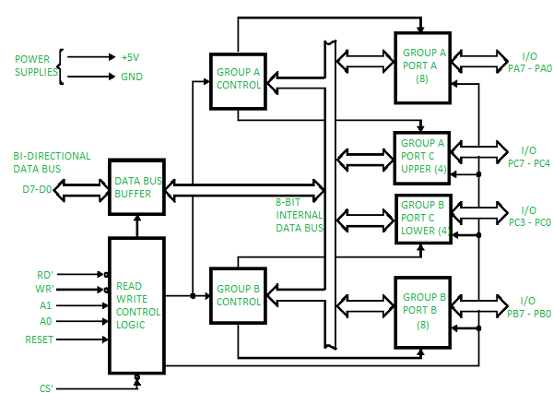

FIG 1: Architecture of 8255 PPI

It consists of 40 pins and operates in +5V regulated power supply. Port C is further divided into two 4-bit ports i.e. port C lower and port C upper and port C can work in either BSR (bit set rest) mode or in mode 0 of input-output mode of 8255. Port B can work in either mode or in mode 1 of input-output mode. Port A can work either in mode 0, mode 1 or mode 2 of input-output mode.

It has two control groups, control group A and control group B. Control group A consist of port A and port C upper. Control group B consists of port C lower and port B.

Depending upon the value if CS’, A1 and A0 we can select different ports in different modes as input-output function or BSR. This is done by writing a suitable word in control register (control word D0-D7).

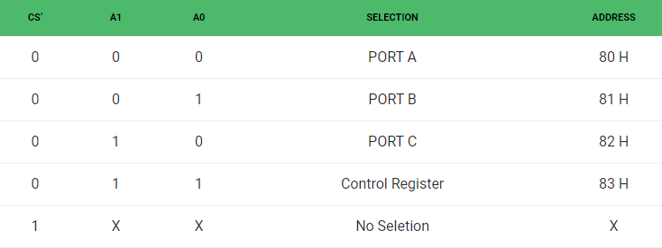

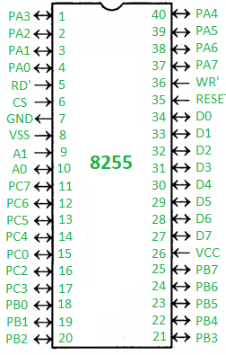

FIG 2: Pin diagram

* **PA0 – PA7 –**Pins of port A
* **PB0 – PB7 –**Pins of port B
* **PC0 – PC7 –**Pins of port C
* **D0 – D7 –**Data pins for the transfer of data
* **RESET –**Reset input
* **RD’ –**Read input
* **WR’ –**Write input
* **CS’ –**Chip select
* **A1 and A0 –**Address pin

**Operating modes –**

1. **Bit set reset (BSR) mode –**  
   If MSB of control word (D7) is 0, PPI works in BSR mode. In this mode only port C bits are used for set or reset.
2. **Input-Output mode –**  
   If MSB of control word (D7) is 1, PPI works in input-output mode. This is further divided into three modes:

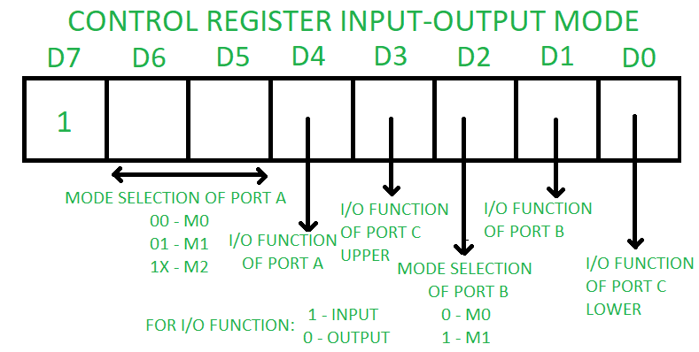

FIG 3: CRW

* + **Mode 0 –**In this mode all the three ports (port A, B, C) can work as simple input function or simple output function. In this mode there is no interrupt handling capacity.
  + **Mode 1 –** Handshake I/O mode or strobbed I/O mode. In this mode either port A or port B can work as simple input port or simple output port, and port C bits are used for handshake signals before actual data transmission. It has interrupt handling capacity and input and output are latched.

Example: A CPU wants to transfer data to a printer. In this case since speed of processor is very fast as compared to relatively slow printer, so before actual data transfer it will send handshake signals to the printer for synchronization of the speed of the CPU and the peripherals.

* + **Mode 2 –** Bi-directional data bus mode. In this mode only port A works, and port B can work either in mode 0 or mode 1. 6 bits port C are used as handshake signals. It also has interrupt handling capacity.

AIM-8255 is configured in mode 0, ie.simple I/O mode. Ports A,B,C are in mode 0. All the ports are in output mode and data is transmitted to the respective ports.

EXPERIMENT-

Port A – Value: 55H

|  |  |  |  |  |  |  |  |
| --- | --- | --- | --- | --- | --- | --- | --- |
| 0 | 1 | 0 | 1 | 0 | 1 | 0 | 1 |

Port B – Value: AAH

|  |  |  |  |  |  |  |  |
| --- | --- | --- | --- | --- | --- | --- | --- |
| 1 | 0 | 1 | 0 | 1 | 0 | 1 | 0 |

Port C – Value: 0FH

|  |  |  |  |  |  |  |  |
| --- | --- | --- | --- | --- | --- | --- | --- |
| 0 | 0 | 0 | 0 | 1 | 1 | 1 | 1 |

CONCLUSION:

In this experiment we learnt about 8255 PPI (Programmable Peripheral Interface). We connected 8086 Micro Processor with 8255PPI. We also learnt about architecture of 8255 PPI.